**DAILY ONLINE ACTIVITIES SUMMARY**

|  |  |  |  |  |  |  |  |  |
| --- | --- | --- | --- | --- | --- | --- | --- | --- |
| **Date:** | **22-05-2020** | | | | | **Name:** | **Shanbhag Atish Manoj** | |
| **Sem & Sec** | **6th - B** | | | | | **USN:** | **4AL17CS085** | |
| **Online Test Summary** | | | | | | | | |
| **Subject** | | **OPERATION RESEARCH** | | | | | | |
| **Max. Marks** | | **30** | | **Score** | | | **30** | |
| **Certification Course Summary** | | | | | | | | |
| **Course** | **Full stack web development** | | | | | | | |
| **Certificate Provider** | | | **Udemy** | | **Duration** | | | **19.5 hours** |
| **Coding Challenges** | | | | | | | | |
| **Problem Statement: 2 java and 1 C program** | | | | | | | | |
| **Status: executed** | | | | | | | | |
| **Uploaded the report in GitHub** | | | | | **Yes** | | | |
| **If yes Repository name** | | | | | <https://github.com/atish-shanbhag/Updates> | | | |
| **Uploaded the report in slack** | | | | | **Yes** | | | |

Online Test Details: (Attach the snapshot and briefly write the report for the same)

First I A of OPERATION RESEARCH

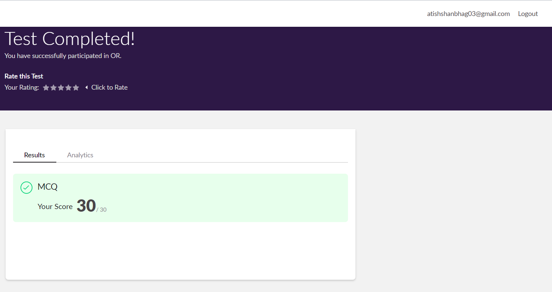

Certification Course Details: (Attach the snapshot and briefly write the report for the same)

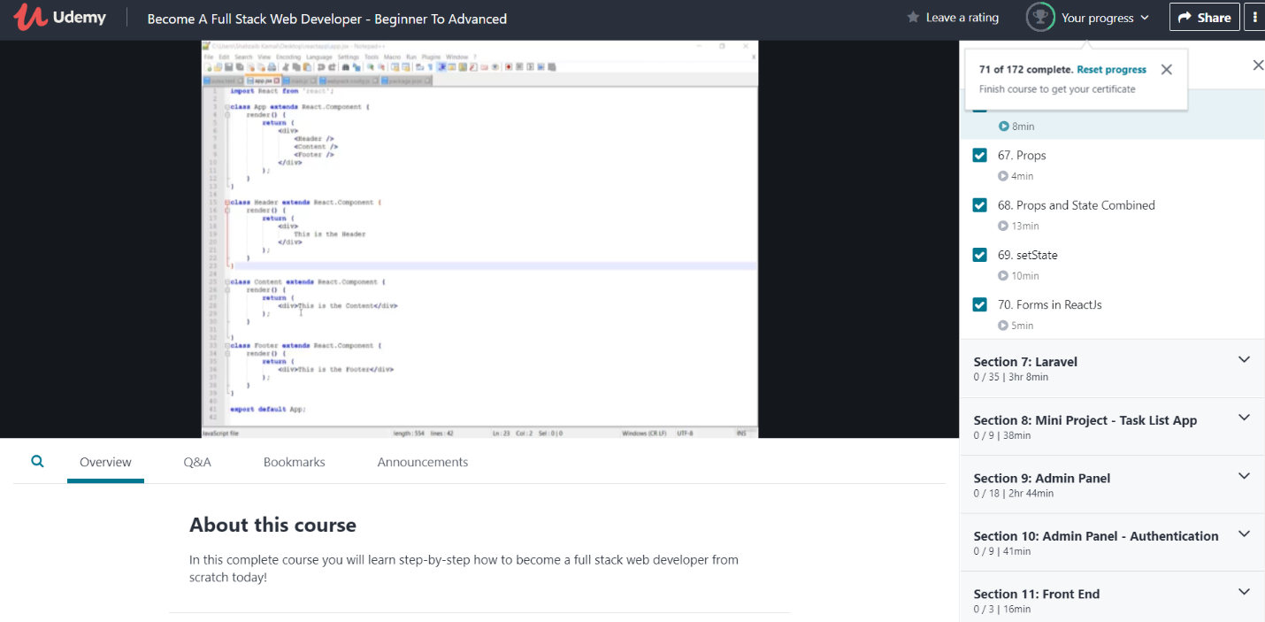

In todays session from 11:00 to 1:00 for online certification I have studied in introduction to react js installation and their very first application, and also get to know the working of react js for dynamically used application and its importance and lot more stuffs.

Coding Challenges Details: (Attach the snapshot and briefly write the report for the same)

Problem statements are available in the GitHub account <https://github.com/atish-shanbhag/Updates>

OUTPUT SCREEN-SHOTS

Program 1(C)

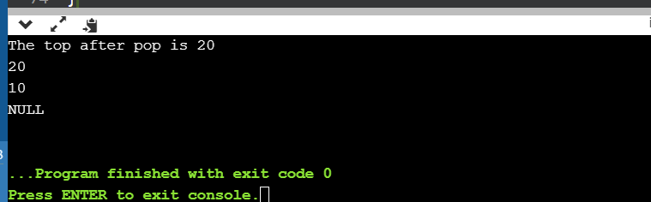

Program 2(Java)

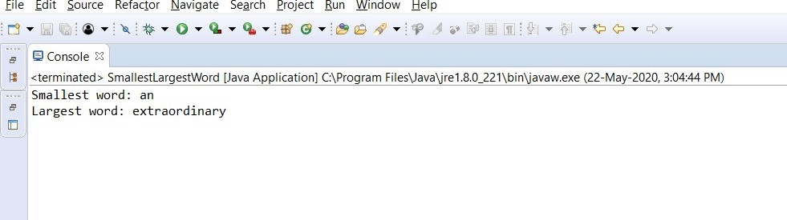

Program 3(Java)

